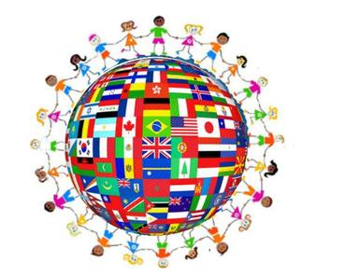 | Human Rights Month  February 2017 | 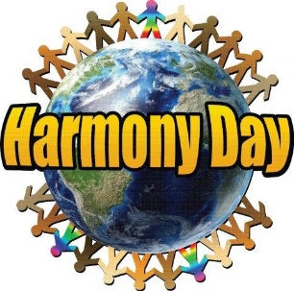
Colour Codes
Blue – SD23 Events
Green – Community Events
Red – National / Provincial Events
Sunday | Monday | Tuesday | Wednesday | Thursday | Friday | Saturday
Month Long Events |  |  | 1 | 2 | 3 | 4
Black History Month  Month of Love  International Development Week |  |  |  | "Harmony Day Living Library"  Middle School Conference – HES
5 | 6 | 7 | 8 | 9 | 10 | 11
 |  |  | Kindness Awareness Week  February 8-14 | A Magical Night of Laughter – Love Gives Back Campaign Rotary Centre for the Arts  http://rotarycentreforthearts.com/event/a-magical-night/ |  | Taste of Home  Mainstreet Centre, 2041 Harvey Avenue 5:30–8:30 pm  www.globalcitizenkelownaorg
12 | 13 | 14 | 15 | 16 | 17 | 18
 | Louis Riel Day  Family Day (BC) | Valentine’s Day  Global School House  February 14 through 21 | Harmony Day  www.harmonyday.ca |  | Random Acts of Kindness Day  https://www.randomactsofkindness.org/
19 | 20 | 21 | 22 | 23 | 24 | 25
 |  | International Mother Language Day | Anti-Bullying/  Pink Shirt Day  Info@pinkshirtday.ca |  |  | Global Children's Village – Lake Country Community Gym, 9950 Main Street 11 am-3:00 pm
26 | 27 | 28

